Half-Space

Definition
# Source: AI Source: Provided by: [Data Path: Persons Table -> ID Column: 1, Name_En Column: Motasem Essam] -> From: [ChatGPT] on [7/25/2026]
A Half-Space is one of the two regions of space determined by a plane.
A plane divides three-dimensional Euclidean space into two disjoint parts, called half-spaces. Each half-space contains the plane itself as its boundary when using the closed half-space convention.
If a plane is denoted by $Π$, the two corresponding half-spaces can be written as:
$$\boxed{H_{1}=\left\{\left(x , y , z\right)∈R^{3}∣ax+by+cz≤d\right\}}$$
and
$$\boxed{H_{2}=\left\{\left(x , y , z\right)∈R^{3}∣ax+by+cz≥d\right\}}$$
where the plane is:
$$\boxed{Π: ax+by+cz=d}$$
The plane $Π$is the boundary separating the two half-spaces.
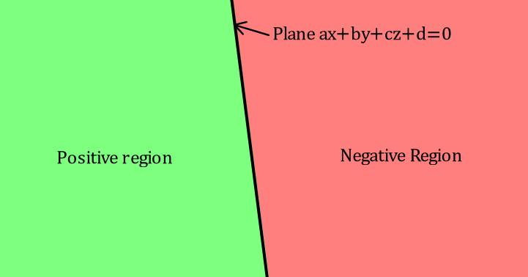
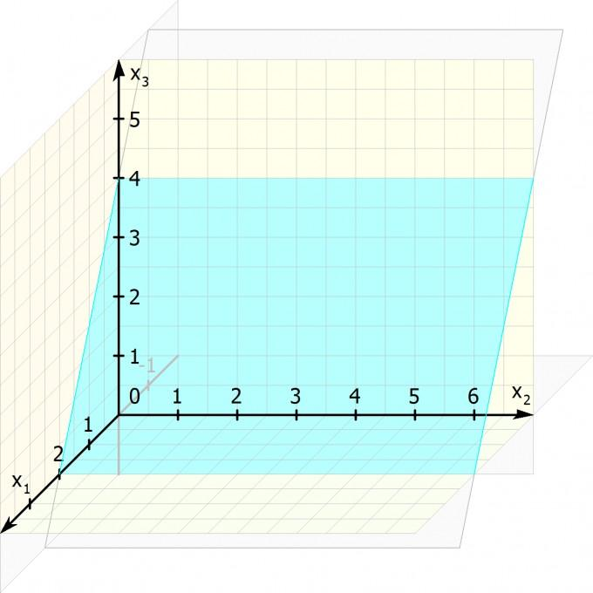
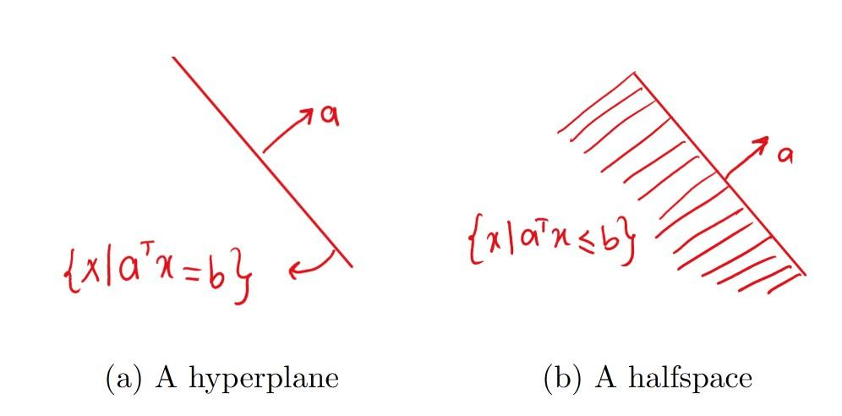

Purpose
# Source: AI Source: Provided by: [Data Path: Persons Table -> ID Column: 1, Name_En Column: Motasem Essam] -> From: [ChatGPT] on [7/25/2026]
The concept of Half-Space is used to:
- Divide three-dimensional space into two sides of a plane.
- Describe the relative position of points with respect to a plane.
- Define regions using linear inequalities.
- Study planes and spatial relationships.
- Represent constraints in geometry.
- Define convex regions and polyhedra.
- Support linear programming and optimization.
- Model boundaries in CAD and computational geometry.

Fundamental Concept
# Source: AI Source: Provided by: [Data Path: Persons Table -> ID Column: 1, Name_En Column: Motasem Essam] -> From: [ChatGPT] on [7/25/2026]
A plane has two sides.
For example, the $xy$-plane:
$$z=0$$
divides $R^{3}$into:
Upper Half-Space
$$\boxed{z≥0}$$
Lower Half-Space
$$\boxed{z≤0}$$
The plane:
$$z=0$$
is their common boundary.
Conceptually:
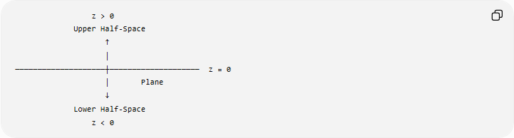
z > 0
Upper Half-Space
↑
│
────────────────────┼──────────────────── z = 0
│ Plane
↓
Lower Half-Space
z < 0

Fundamental Elements
# Source: AI Source: Provided by: [Data Path: Persons Table -> ID Column: 1, Name_En Column: Motasem Essam] -> From: [ChatGPT] on [7/25/2026]
A Half-Space consists of:

1. Boundary Plane
# Source: AI Source: Provided by: [Data Path: Persons Table -> ID Column: 1, Name_En Column: Motasem Essam] -> From: [ChatGPT] on [7/25/2026]
The plane that divides space.
$$Π:ax+by+cz=d$$

2. One Side of the Plane
# Source: AI Source: Provided by: [Data Path: Persons Table -> ID Column: 1, Name_En Column: Motasem Essam] -> From: [ChatGPT] on [7/25/2026]
One half of three-dimensional space.

3. Opposite Half-Space
# Source: AI Source: Provided by: [Data Path: Persons Table -> ID Column: 1, Name_En Column: Motasem Essam] -> From: [ChatGPT] on [7/25/2026]
The other side of the same plane.

4. Boundary
# Source: AI Source: Provided by: [Data Path: Persons Table -> ID Column: 1, Name_En Column: Motasem Essam] -> From: [ChatGPT] on [7/25/2026]
The boundary of each closed half-space is the dividing plane:
$$\boxed{∂H=Π}$$

Mathematical Representation
# Source: AI Source: Provided by: [Data Path: Persons Table -> ID Column: 1, Name_En Column: Motasem Essam] -> From: [ChatGPT] on [7/25/2026]
Consider the plane:
$$Π:ax+by+cz=d$$
The expression
$$ax+by+cz-d$$
determines which side of the plane a point occupies.
First Half-Space
$$\boxed{ax+by+cz≥d}$$
Second Half-Space
$$\boxed{ax+by+cz≤d}$$
The plane itself satisfies:
$$ax+by+cz=d$$
Therefore, the two closed half-spaces are:
$$\boxed{H_{1}=\left\{\left(x , y , z\right)∣ax+by+cz≥d\right\}} \\ \boxed{H_{2}=\left\{\left(x , y , z\right)∣ax+by+cz≤d\right\}}$$

Open and Closed Half-Spaces
# Source: AI Source: Provided by: [Data Path: Persons Table -> ID Column: 1, Name_En Column: Motasem Essam] -> From: [ChatGPT] on [7/25/2026]
There are two important conventions.

Closed Half-Space
# Source: AI Source: Provided by: [Data Path: Persons Table -> ID Column: 1, Name_En Column: Motasem Essam] -> From: [ChatGPT] on [7/25/2026]
A closed half-space includes its boundary plane.
For example:
$$\boxed{z≥0}$$
includes:
$$z=0$$
Therefore:
$$\boxed{∂H⊆H}$$

Open Half-Space
# Source: AI Source: Provided by: [Data Path: Persons Table -> ID Column: 1, Name_En Column: Motasem Essam] -> From: [ChatGPT] on [7/25/2026]
An open half-space excludes its boundary plane.
For example:
$$\boxed{z>0}$$
contains only points strictly above the plane $z=0$.
Similarly:
$$\boxed{z<0}$$
contains only points strictly below it.
Thus:
$$\boxed{\text{Closed half-space}=\text{one side + boundary}} \\ \boxed{\text{Open half-space}=\text{one side without boundary}}$$

Example 1: The $xy$-Plane
# Source: AI Source: Provided by: [Data Path: Persons Table -> ID Column: 1, Name_En Column: Motasem Essam] -> From: [ChatGPT] on [7/25/2026]
The plane:
$$z=0$$
divides space into:
$$H_{1}=\left\{\left(x , y , z\right)∣z≥0\right\}$$
and:
$$H_{2}=\left\{\left(x , y , z\right)∣z≤0\right\}$$
A point such as:
$$P=\left(2 , 3 , 5\right)$$
belongs to $H_{1}$.
A point:
$$Q=\left(1 , 4 , -2\right)$$
belongs to $H_{2}$.
A point:
$$R=\left(5 , 2 , 0\right)$$
lies on the boundary plane and therefore belongs to both closed half-spaces.

Example 2: General Plane
# Source: AI Source: Provided by: [Data Path: Persons Table -> ID Column: 1, Name_En Column: Motasem Essam] -> From: [ChatGPT] on [7/25/2026]
Consider:
$$2x+y-z=4$$
The two closed half-spaces are:
$$\boxed{2x+y-z≥4}$$
and:
$$\boxed{2x+y-z≤4}$$
Consider:
$$P=\left(2 , 2 , 1\right)$$
Then:
$$2\left(2\right)+2-1=5$$
Since:
$$5>4$$
$P$lies in the first half-space.

Determining Which Half-Space Contains a Point
# Source: AI Source: Provided by: [Data Path: Persons Table -> ID Column: 1, Name_En Column: Motasem Essam] -> From: [ChatGPT] on [7/25/2026]
For a plane:
$$ax+by+cz=d$$
and point:
$$P=\left(x_{0} , y_{0} , z_{0}\right)$$
calculate:
$$S=ax_{0}+by_{0}+cz_{0}-d$$
Then:

Value of $S$ | Position
$$S>0$$ | One side of the plane
$$S=0$$ | On the plane
$$S<0$$ | Opposite side
This provides a simple algebraic test for the position of a point relative to a plane.

Half-Space in Two Dimensions
# Source: AI Source: Provided by: [Data Path: Persons Table -> ID Column: 1, Name_En Column: Motasem Essam] -> From: [ChatGPT] on [7/25/2026]
The same concept has a two-dimensional analogue.
A line divides a plane into two half-planes.
For example:
$$x=0$$
divides the $xy$-plane into:
$$x≥0$$
and:
$$x≤0$$
Therefore:
$$\boxed{\text{Line in 2D}→\text{two half-planes}}$$
while:
$$\boxed{\text{Plane in 3D}→\text{two half-spaces}}$$
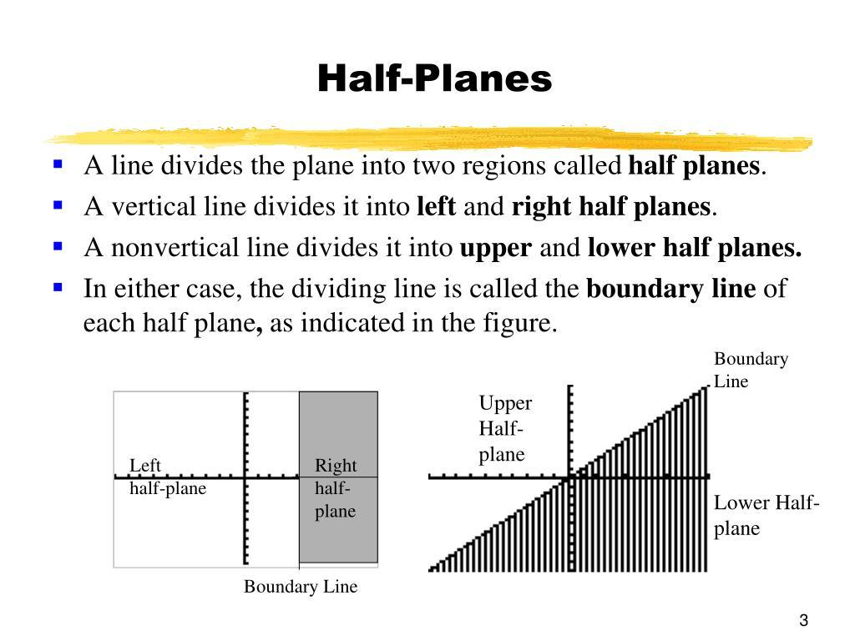
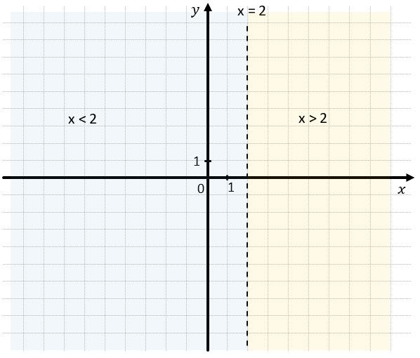
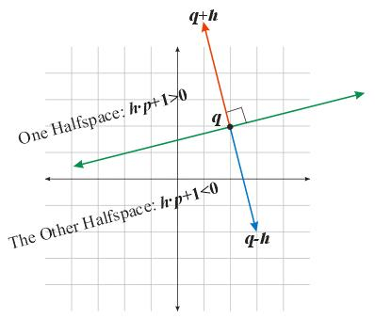

Boundary of a Half-Space
# Source: AI Source: Provided by: [Data Path: Persons Table -> ID Column: 1, Name_En Column: Motasem Essam] -> From: [ChatGPT] on [7/25/2026]
For the closed half-space:
$$H=\left\{\left(x , y , z\right)∣ax+by+cz≥d\right\}$$
its boundary is:
$$\boxed{∂H=\left\{\left(x , y , z\right)∣ax+by+cz=d\right\}}$$
Thus:
$$\boxed{∂H=Π}$$
The boundary of a half-space is therefore a plane.

Complementary Half-Spaces
# Source: AI Source: Provided by: [Data Path: Persons Table -> ID Column: 1, Name_En Column: Motasem Essam] -> From: [ChatGPT] on [7/25/2026]
The two closed half-spaces together cover all of three-dimensional space:
$$\boxed{H_{1}∪H_{2}=R^{3}}$$
Their common portion is exactly the boundary plane:
$$\boxed{H_{1}∩H_{2}=Π}$$
For the corresponding open half-spaces:
$$H_{1}^{∘}=\left\{ax+by+cz>d\right\} \\ H_{2}^{∘}=\left\{ax+by+cz<d\right\}$$
we have:
$$\boxed{H_{1}^{∘}∩H_{2}^{∘}=∅}$$
and:
$$\boxed{H_{1}^{∘}∪H_{2}^{∘}=R^{3}∖Π}$$

Half-Space and Containment
# Source: AI Source: Provided by: [Data Path: Persons Table -> ID Column: 1, Name_En Column: Motasem Essam] -> From: [ChatGPT] on [7/25/2026]
A half-space is itself a region of three-dimensional space.
A geometric object can be contained in a half-space.
For example:
$$\boxed{V⊆H}$$
means that the entire solid $V$lies within the half-space.
Similarly:
$$l⊆H$$
means that an entire line lies in that half-space.
This makes half-spaces important in studying geometric containment.

Half-Space and Boundary-Touching
# Source: AI Source: Provided by: [Data Path: Persons Table -> ID Column: 1, Name_En Column: Motasem Essam] -> From: [ChatGPT] on [7/25/2026]
A solid can be contained in a closed half-space while touching its boundary plane.
For example:
$$V⊆H$$
and:
$$V∩∂H≠∅$$
means the solid remains inside the half-space but touches its boundary.
If:
$$V∩∂H=∅$$
then the solid lies strictly away from the boundary plane.
This connects Half-Space with the concepts of Boundary Point, Boundary-Touching Containment, and Strict Interior Containment.

Half-Space and Convexity
# Source: AI Source: Provided by: [Data Path: Persons Table -> ID Column: 1, Name_En Column: Motasem Essam] -> From: [ChatGPT] on [7/25/2026]
A half-space is a convex set.
If:
$$P,Q∈H$$
then every point on the segment joining them also belongs to $H$:
$$\boxed{\overset{‾}{PQ}⊆H}$$
This property is extremely important.
For example, if:
$$ax+by+cz≤d$$
and both $P$and $Q$satisfy the inequality, every point between them also satisfies it.

Half-Space and Polyhedra
# Source: AI Source: Provided by: [Data Path: Persons Table -> ID Column: 1, Name_En Column: Motasem Essam] -> From: [ChatGPT] on [7/25/2026]
Many three-dimensional geometric regions can be constructed as intersections of half-spaces.
For example:
$$\boxed{P=H_{1}∩H_{2}∩H_{3}∩⋯∩H_{n}}$$
This is the mathematical foundation of many polyhedra.
A cube, for example, can be described using six inequalities:
$$0≤x≤a \\ 0≤y≤b \\ 0≤z≤c$$
Each inequality represents a half-space, and their intersection produces the rectangular solid.
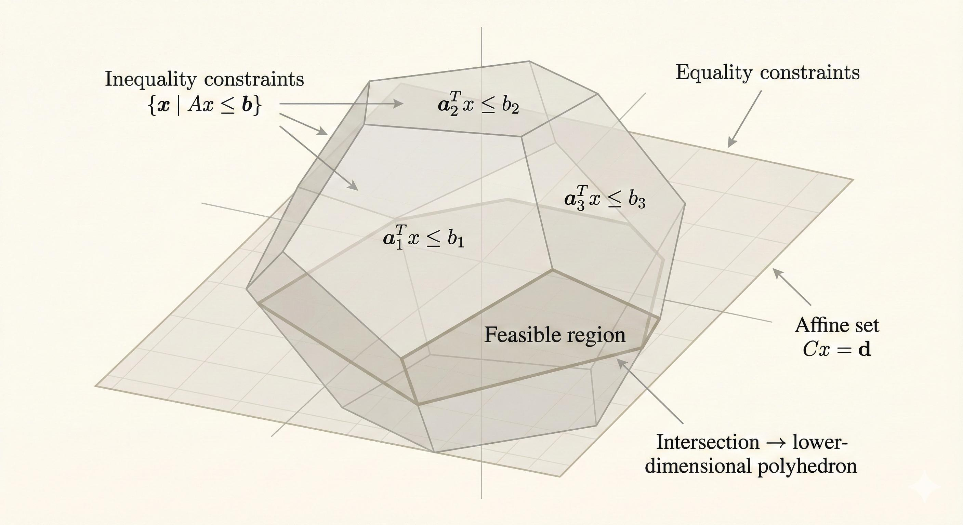
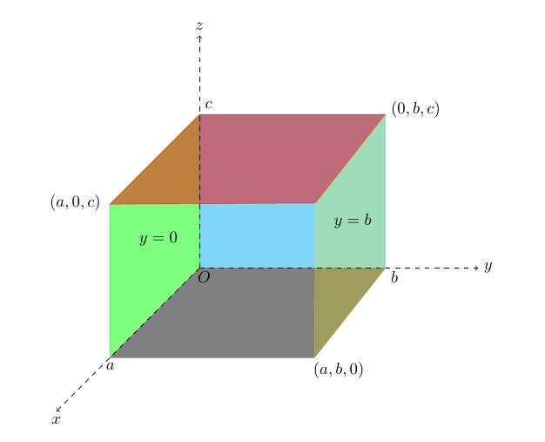
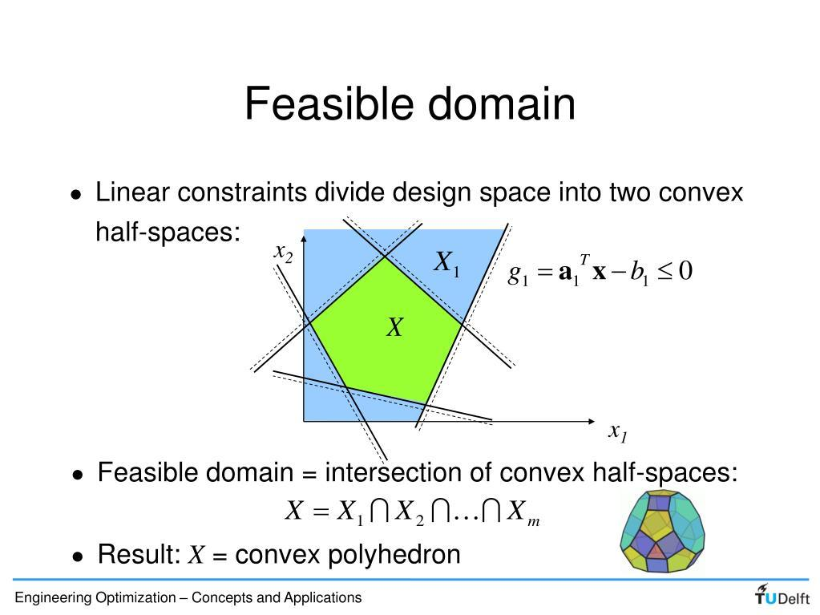
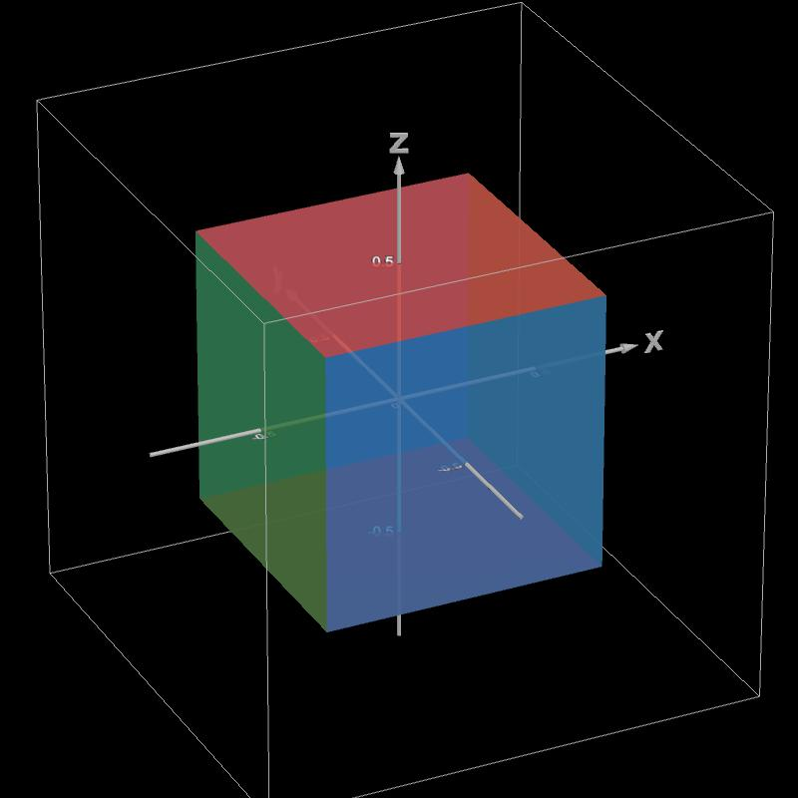
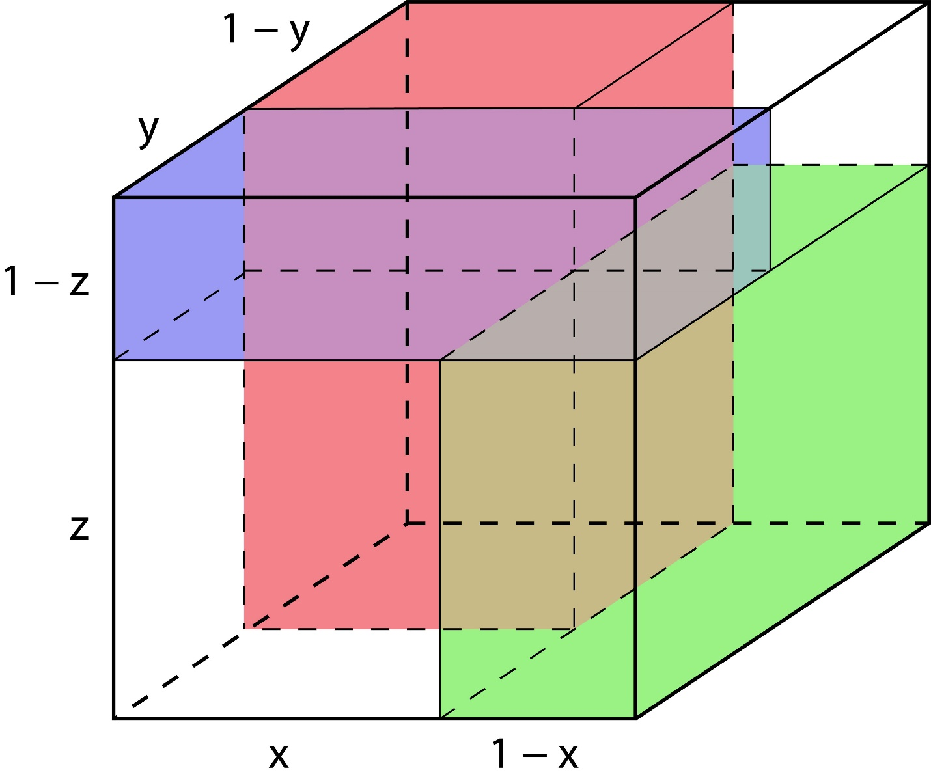

Main Properties

1. A Plane Determines Two Half-Spaces
# Source: AI Source: Provided by: [Data Path: Persons Table -> ID Column: 1, Name_En Column: Motasem Essam] -> From: [ChatGPT] on [7/25/2026]
Every plane divides Euclidean 3-space into two sides.

2. Each Half-Space Has One Boundary Plane
# Source: AI Source: Provided by: [Data Path: Persons Table -> ID Column: 1, Name_En Column: Motasem Essam] -> From: [ChatGPT] on [7/25/2026]
$$\boxed{∂H=Π}$$
for the corresponding closed half-space.

3. Closed Half-Spaces Include Their Boundary
# Source: AI Source: Provided by: [Data Path: Persons Table -> ID Column: 1, Name_En Column: Motasem Essam] -> From: [ChatGPT] on [7/25/2026]
$$ax+by+cz≤d$$
includes equality.

4. Open Half-Spaces Exclude Their Boundary
# Source: AI Source: Provided by: [Data Path: Persons Table -> ID Column: 1, Name_En Column: Motasem Essam] -> From: [ChatGPT] on [7/25/2026]
$$ax+by+cz<d$$
excludes equality.

5. Half-Spaces Are Convex
# Source: AI Source: Provided by: [Data Path: Persons Table -> ID Column: 1, Name_En Column: Motasem Essam] -> From: [ChatGPT] on [7/25/2026]
Every segment connecting two points in the same half-space remains within that half-space.

6. The Two Closed Half-Spaces Cover Space
# Source: AI Source: Provided by: [Data Path: Persons Table -> ID Column: 1, Name_En Column: Motasem Essam] -> From: [ChatGPT] on [7/25/2026]
$$\boxed{H_{1}∪H_{2}=R^{3}}$$

7. Their Intersection Is the Boundary Plane
# Source: AI Source: Provided by: [Data Path: Persons Table -> ID Column: 1, Name_En Column: Motasem Essam] -> From: [ChatGPT] on [7/25/2026]
$$\boxed{H_{1}∩H_{2}=Π}$$
for the two corresponding closed half-spaces.

Half-Space vs Half-Plane
# Source: AI Source: Provided by: [Data Path: Persons Table -> ID Column: 1, Name_En Column: Motasem Essam] -> From: [ChatGPT] on [7/25/2026]
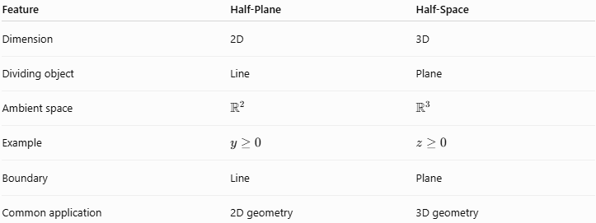
Feature | Half-Plane | Half-Space
Dimension | 2D | 3D
Dividing object | Line | Plane
Ambient space | $$R^{2}$$ | $$R^{3}$$
Example | $$y≥0$$ | $$z≥0$$
Boundary | Line | Plane
Common application | 2D geometry | 3D geometry

Half-Space vs Plane
# Source: AI Source: Provided by: [Data Path: Persons Table -> ID Column: 1, Name_En Column: Motasem Essam] -> From: [ChatGPT] on [7/25/2026]
A plane is the boundary that divides space.
A half-space is one of the two sides produced by that division.
Thus:
$$\boxed{\text{Plane}=\text{boundary}} \\ \boxed{\text{Half-Space}=\text{one side of the plane}}$$

Half-Space vs Solid
# Source: AI Source: Provided by: [Data Path: Persons Table -> ID Column: 1, Name_En Column: Motasem Essam] -> From: [ChatGPT] on [7/25/2026]
A solid is generally a bounded three-dimensional region.
A half-space is normally unbounded.
For example:
$$x≥0$$
extends infinitely in the $x$, $y$, and $z$directions.
Therefore:
$$\boxed{\text{Half-space is generally unbounded}}$$
while a cube is bounded.

Real-World Applications
# Source: AI Source: Provided by: [Data Path: Persons Table -> ID Column: 1, Name_En Column: Motasem Essam] -> From: [ChatGPT] on [7/25/2026]
Architecture
Half-spaces can represent restrictions imposed by walls, floors, and structural planes.
Engineering
Used to define allowable spatial regions and constraints.
CAD
Boolean operations and solid modeling frequently use plane-based spatial partitions.
Robotics
Half-space constraints can describe forbidden or allowed regions.
Computer Graphics
Planes and half-spaces are used for clipping objects and defining viewing regions.
Linear Programming
Linear inequalities define feasible regions as intersections of half-spaces.
Computational Geometry
Half-spaces are fundamental components of convex hulls, polyhedra, and spatial partitioning.

Key Points
# Source: AI Source: Provided by: [Data Path: Persons Table -> ID Column: 1, Name_En Column: Motasem Essam] -> From: [ChatGPT] on [7/25/2026]
- A Half-Space is one of the two regions into which a plane divides $R^{3}$.
- A plane has the form:
$$\boxed{ax+by+cz=d}$$
- The two closed half-spaces are:
$$\boxed{ax+by+cz≤d}$$
and:
$$\boxed{ax+by+cz≥d}$$
- The boundary of each closed half-space is the plane:
$$\boxed{∂H=Π}$$
- A closed half-space includes its boundary.
- An open half-space excludes its boundary.
- Half-spaces are convex.
- A plane divides 3D space into two half-spaces.
- Intersections of half-spaces can form bounded regions such as polyhedra.

Conclusion
# Source: AI Source: Provided by: [Data Path: Persons Table -> ID Column: 1, Name_En Column: Motasem Essam] -> From: [ChatGPT] on [7/25/2026]
A Half-Space is one of the two portions of three-dimensional Euclidean space separated by a plane. It provides a fundamental way to describe which side of a plane a point or geometric object occupies.
The central representation is:
$$\boxed{H=\left\{\left(x , y , z\right)∈R^{3}∣ax+by+cz≤d\right\}}$$
or the opposite half-space:
$$\boxed{H=\left\{\left(x , y , z\right)∈R^{3}∣ax+by+cz≥d\right\}}$$
Half-spaces are fundamental in solid geometry, coordinate geometry, convex geometry, linear inequalities, polyhedra, CAD, robotics, and computational geometry.

